HOW TO CREATE A LAN NETWORK BETWEEN TWO PC’S.
Introduction.
Creating a LAN network between two computers we can use cisco packet tracer to create a visual network creation.
Using the Cisco Packet Tracer.
We use the cisco packet tracer for the visual connection between pc’s and other devices. It shows the setup of connections between devices. The steps involved in these connections include;
- Here, after opening the packet tracer, we take the pc icons by clicking on the end device which is located at the bottom left of our page. After we click this end device we see under sets of other icons, then we click the end device. Click the pc icon the place on the logical work space.
- I used the copper cross over to connect the 2 PC’s.
- Here we are to configure the PC’s by assigning IP addresses to them. To do that we click on the each PC, go to desktop, then click on IP configuration making sure the setting is on static so as to assign its IP address.
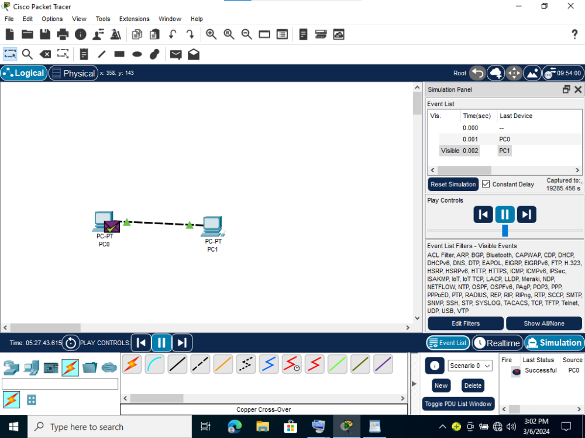
- I check to see if both of the computers are well connected by running a command prompt making sure there are no losses (loss 0%).

HOW TO CONNECT TWO COMPUTERS TO LAN USING AN RJ45 ETHERNET CABLE
INTRODUCTION
Ethernet is the traditional technology for connecting devices in a wired Local area network (LAN). It enables devices to communicate with each other via a protocol, which is a set of rules or common network language.
PROCEDURE
- I connected one end of the rj45 Ethernet cable to the Ethernet port of computer A and the other end to the rj45 port of computer B.
- On computer A, I went to network and sharing center to set the Ethernet network to be a private network by going to local security policy.
- I went to advanced sharing options to make the network discoverable and enabled printer sharing.
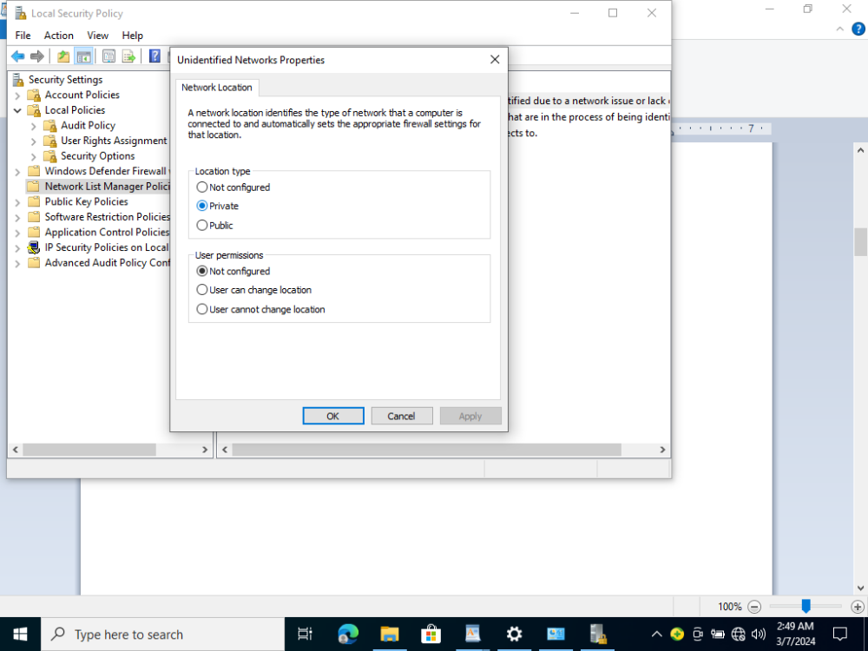
4. I proceeded to adapter options in network and sharing center to assign an IP address to computer A which was 192.168.1.1 and the subnet mask applied automatically.
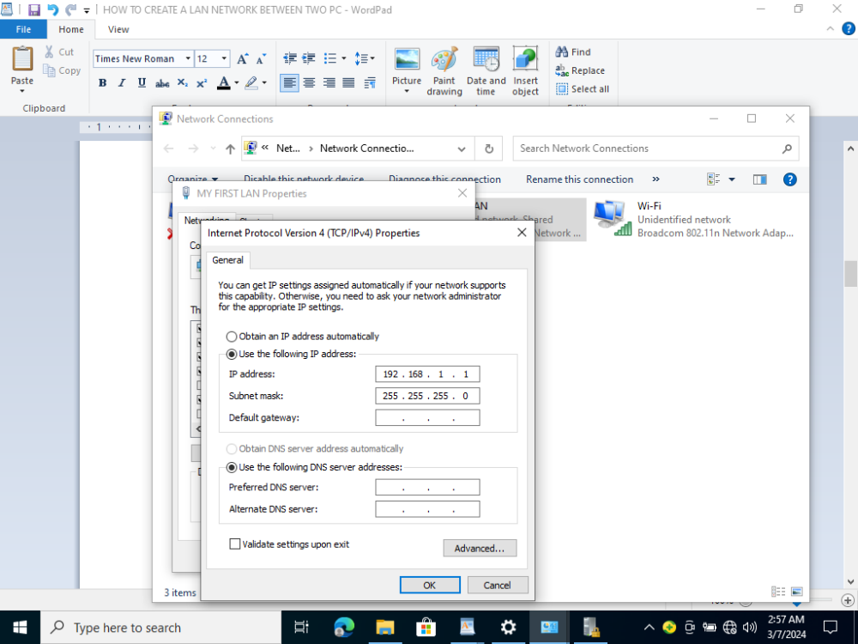
5. I proceeded to file explorer, then clicked on the network option to check the computer is connected.
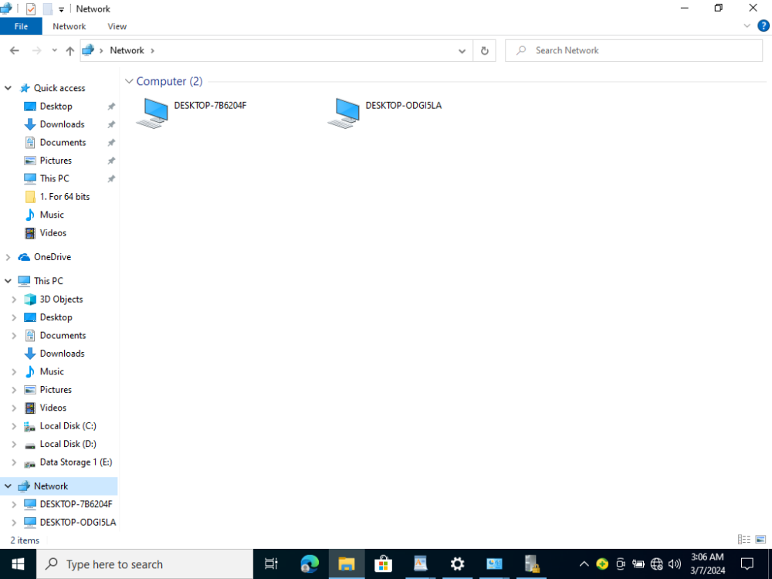
6. I repeated all the above steps on computer B but used 192.168.1.2 as the IP address.
7. After the two computers were connected successfully, i shared documents between the two computers to ensure they were properly connected and it was successful.
